1. Let’s see how to add validation in mongoDb?
2. **Ways**:
   1. **When adding collection first time**:
3. **When adding collection first time**:  
   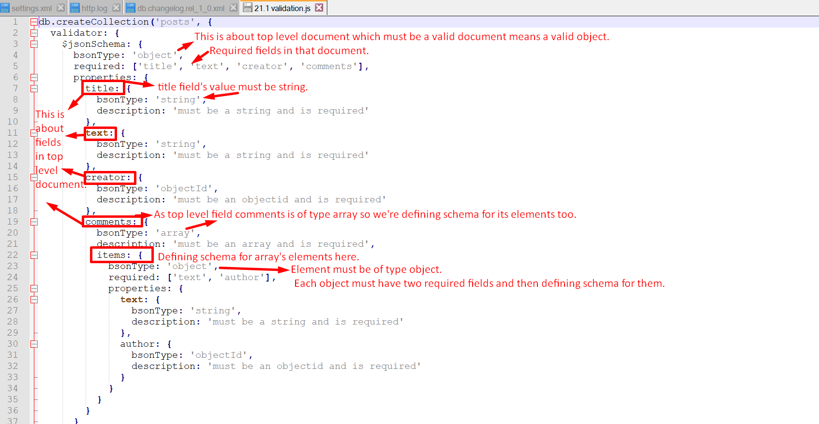
   1. **db.createCollection(“posts”, {configureCollection here}):** Create collection explicitly when you want to configure the collection.
      1. “posts”: name of the collection.
      2. validator: One of the important pieces of configuration where the incoming data with insert and update must be validated against.
      3. @jsonSchema: Here we’re saying that our validator is json schema (there are others too).
      4. bsonType:”object”: Here we’re saying that everything that gets added to the collection should be a valid document or object.
      5. Required: The fields which are required when a document is added.
4. How to add the above defined schema?
   1. Just run the code from the command prompt.  
      
5. 
6. 